Revisiting the Congressional Research Service 2016 nbC Report
by Joseph DeMaio, ©2024
(Dec. 21, 2024) — Introduction
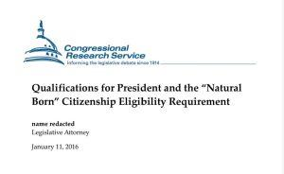
Source
Once more, faithful P&E readers and students of the Constitution’s “natural born Citizen” (“nbC”) Eligibility Clause – not a concocted, fictitious “’natural born’ Citizenship Clause” – grab your preferred caffeinated beverage and find a comfortable chair, because what follows gets a bit convoluted.
Ready?
The “natural born Citizen” (“nbC”) issue remains unresolved, but at least the threat of yet another ineligible president at 1600 Pennsylvania Avenue has been avoided through the Nov. 5, 2024 election of Donald Trump and the rejection of Kamala Harris. That fact will remain true, of course, only if before January 20, 2025 (a) the slug at 1600 (aka “Brandon”) does not resign or (b) he avoids duplicating the “Pelosi Polka” down a flight of stairs, cracks his head open and demises on the spot. Either way, VP Harris would become President, if only until noon on Jan. 20, 2025.
The Elg Ellipsis Prelude
As P&E readers will also recall, your humble servant has for years criticized the Congressional Research Service (“CRS”) for playing “fast and loose” with the words of U.S. Supreme Court decisions. As but one example, through the use of grammatical ellipses, the actual words of the Supreme Court’s decision in Perkins v. Elg, 307 U.S. 325 (1939) were in at least two instances – a CRS “memo” dated April 3, 2009 and a CRS “Report” dated Nov. 14, 2011 – substantively altered.
To briefly refresh the memory, through the use of the ellipsis, by erasing a date of the U.S. naturalization of a Prussian-German man named Steinkauler (“the Elder”), the CRS was able to portray, falsely, that the Elg Court had recognized that his son, Steinkauler the Younger, born in St. Louis, was eligible to the presidency – and thus, necessarily, an nbC – despite the illusory painting of his father as being a foreigner when the son was born. The same portrayal applied to the subject of the case, Marie Elg.
In fact, under the original language of the Court in Elg, the son was in reality always an nbC, and for the same reasons, so was Marie Elg. But both the Steinkauler son and Marie Elg had to be portrayed as being born to foreign fathers in order to fit the CRS preferred narrative. Hence, the 2009 (CRS memo) and 2011 (CRS Report) ellipses.
If the son (or Marie Elg) could be shown as being born to an alien father, yet nonetheless eligible to the presidency, the related illusion that parental citizenship was purportedly of no concern to the Founders would be fortified. Oddly enough, that illusion would also support the claimed eligibility of one Barack Hussein Obama, II, regardless of the authenticity of his Hawai’ian birth certificate. Thus altered, the CRS 2009 memo and the 2011 Report could more easily bamboozle the 535 members of Congress, 9 Justices of the Supreme Court and millions of voters that Obama was “eligible” to the presidency regardless of his birth certificate bona fides.
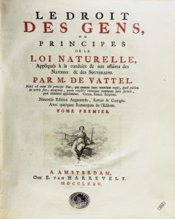
Wikimedia Commons, public domain
On the other hand, the CRS-concocted illusion would violate the principles of § 212, Book 1, Ch. 19 of The Law of Nations (“§ 212”) by Emer de Vattel, the Swiss attorney, judge and legal philosopher upon whom, it is posited, the Founders relied in crafting the nbC Eligibility Clause. Under § 212, a natural born citizen is one born in a country to two parents who both are already citizens of that country. Thus, the debate over the definition of an nbC, as understood by the Founders, persists. As discussed below, the “Elg” ellipsis was reversed in a 2016 CRS Report.
The details of this CRS linguistic sleight of hand (and computer keyboard taps) have been discussed frequently over the years at The P&E, for example, here and here. Whether the ellipsis alterations and their substantive impact were intentional remains to be confirmed…, but a number of indicia point that way.
That said, the intentional insertion of an ellipsis at all to erase substantive language from a quote in a Supreme Court opinion, where one was unnecessary, and altering the meaning of the Court’s ruling, cannot be justified: the Supreme Court said what it originally intended in Elg, and not what the CRS claimed it said or intended to say. But to the casual reader – including members of Congress, many of whom often don’t even read the text of bills before them – the ellipses make it appear that the Supreme Court ruled in 1939 that a person born here to an alien father was nonetheless eligible to the presidency.
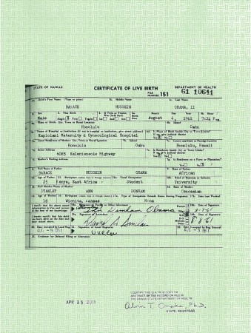
https://obamawhitehouse.archives.gov/sites/
default/files/rss_viewer/birth-certificate-long-form.pdf
As noted, this deceptive conclusion perfectly fit the situation of Barack Hussein Obama, II – whose father was never a U.S. citizen – and provided a convenient additional defense against claims that he was ineligible because his Hawai’ian birth certificate was a forgery. But the 2016 Report did a number of additional things besides erasing the prior “Elg ellipsis” from the CRS 2011 Report. That erasure had the same effect on the CRS 2009 nbC “memorandum,” but the document actually “corrected” was the 2011 CRS Report.
The Reverse Memory-Holing and the Additional Assertions
However, the most recent icing on the linguistic chicanery cake occurred January 11, 2016 when the CRS issued its “revised” 51-page Report captioned, “Qualifications for President and the ‘Natural Born’ Citizenship Eligibility Requirement.” This 2016 CRS “product” bears the same title and reference serial number of “R42097” as the 2011 CRS Report which it purports to “revise” and “change.”
As already noted, in the 2016 document, the CRS – among other things – erased and “undid” its prior ellipsis, making it appear as if “nothing had happened.” See and compare the 2011 Report (at 45) with the 2016 Report (at 43). Your servant addressed that event here. And while your servant has in the past focused on the 2016 Report primarily for its “reverse-Memory-Holing” of its prior ellipsis gambit, other parts of the Report, altering the language and re-formatting the 2011 Report, raise similar problematic issues.
Concededly, under the CRS nbC narrative, and quite apart from the Elg ellipsis and its erasure, the persons being discussed by the Supreme Court in the Elg case at issue – Steinkauler the son and Marie Elg – were both a “citizen at birth” or a “citizen by birth” under the 14th Amendment. Accordingly, the fact that their respective fathers may have actually been foreigners on the dates of birth – instead of being merely portrayed as foreigners through the ellipses – did not matter. According to the CRS narrative, the only thing that matters is that the person is a U.S. “citizen at birth” or a “citizen by birth,” equating those two conditions with status as an nbC under the Constitution. Respectfully, your servant posits that the Founders would disagree. Vehemently.
Besides the “Elg ellipsis erasure” by the CRS, the 2016 Report dismisses altogether (as do the 2009 and 2011 CRS “products”) the relevance of Emer de Vattel and § 212 as having any impact at all on the thinking of the Framers when fashioning the nbC eligibility restriction. This dismissal is based, in part, on the CRS argument that because the treatise was not then available to the Founders in an English translation, they would have been flummoxed over its words.
This fatuous CRS argument ignores, of course, the fact that many if not most of the delegates at the 1787 Philadelphia Constitutional Convention – including John Jay, the author of the famous “hint” letter to George Washington – well understood, spoke and could compose in French.
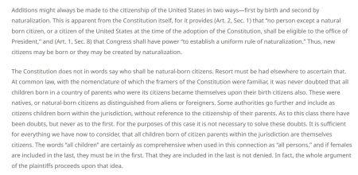
The Report also attempts to distinguish the Supreme Court’s decision in Minor v. Happersett, 88 U.S. 162 (1875), by mis-characterizing the Court’s words regarding those who, in the nomenclature of the time, were understood by the Founders to be nbC’s as distinguished from those as to whom there existed “doubts” regarding their status as true nbC’s. See CRS 2016 Report at 29, n. 135.
As to that curious claim, the 2016 Report asserts that the Court’s observations regarding those who the Founders considered to be nbCs was “dicta.” This CRS blunder gets it exactly backwards. The error is addressed and explained here. The Minor Court’s “not necessary to solve” statement was referring to the issue of parental citizenship of those persons burdened with doubts as to their nbC status, rather than those persons as to whom there had “never” been any nbC doubts…“ (Emphasis added)
The Court’s comments as to those persons burdened with “doubts” actually was dicta, as opposed to its comments relating to those who were never burdened with nbC “doubts.” Indeed, because Virginia Happersett was herself a nbC – see Virginia’s Biography – Virginia and Francis Minor Memorial Institute; accord, Minor at 163 – the Court’s “no doubts” comments might instead well be recognized as being part of the essential “holding” in the case. Moreover, even if deemed not part of the actual holding, but somehow “dictum,” the comments should be acknowledged as being “judicial dictum,” a species of dictum that has binding, precedential weight in lower courts, as discussed here.
Finally, the 2016 Report asserts (at p. 3, coupled with fn. 13) that “[t]he weight of scholarly legal and historical opinion, as well as the consistent case law in the United States, also supports the notion that “natural born Citizen” means one who is a U.S. citizen “at birth” or “by birth.” (Emphasis added).
This flawed claim completely ignores the Supreme Court’s opinion in Minor – wholly apart from the CRS misunderstanding of that which was, and that which was not, dictum in the case –and is further undermined by the CRS addition in footnote 13 of a citation to the 2015 Harvard Law Review Journal article “On the Meaning of Natural Born Citizen” by Paul Clement and Neal Katyal, purporting to support the CRS narrative.
For myriad reasons far too numerous to detail here, that article is addressed and critiqued here, here, and here.
The Anomalies
But I digress. A major point of this offering is that, after bamboozling Congress; the electorate; academia; and scores of media talking heads with the 2009 and 2011 CRS “products,” and as already noted, on Jan. 11, 2016, a “revised” version of the CRS R42097 “product” was issued which reversed the prior ellipses in the 2009 and 2011 “products” and restored the Supreme Court’s original accurate language. And as stated, the result was to make it appear that the ellipses had never been deployed at all.
And here emerge the current anomalies: strangely, when one tries to access the 2016 Report through the CRS official document “search” sub-website, using the document serial number for the report, “R42097,” the following pops up: “[0] results for R42097.” Alternatively, using instead the full title of the report at the same CRS website produces: “[0] results for “Qualifications for President and the ‘Natural Born’ Citizenship Eligibility Requirement.”
Translation: one cannot access the 2016 report at all on the website of the creator of the report: the Congressional Research Service itself. Although the 2016 document is an official “Report” of the CRS, it cannot be accessed on the official “CRS Reports” website using either the full title of the document or its serial number. Whether using the serial number of the report (R42097) or the title of the report, identical error messages result.
In addition, if one enters the full title of the 2016 document into a general Internet search engine query box (e.g., Google), the search is re-directed to the 2011 CRS Report. The same re-direction happens if the title is entered into the Wikipedia search box. And on the website entitled “FAS Project on Government Secrecy” operated by the “Federation of American Scientists,” any attempt to access the 2016 Report again redirected the reader to the CRS 2011 Report at the time of this writing, rather than the 2016 Report, but now yields a “404 Not Found” message.
Against this backdrop, a cynic might be tempted to leap to the conclusion that someone – or some entity (including the CRS) – does not want people accessing the 2016 document. Perhaps there is concern that the reversal of the Elg ellipses found in the CRS 2009 memo and the CRS 2011 Report would be discovered (other than by learning of them at The P&E), causing people to ask unwanted questions. Memo to P&E readers: your servant likes to pose such questions.
Note, however, that there are two non-CRS-associated Internet websites where the original 2016 Report can still be accessed. First, at the SCRIBD.com website, uploaded courtesy of “ProtectOurLiberty.org” – a website operated and maintained by another familiar name here at The P&E, CDR. Charles F. Kerchner, Jr. (Ret.) – a .pdf image of the original 2016 Report exists.
In addition, another privately-maintained website, “EveryCRSReport.com) operated by the “American Governance Institute” posts both a reformatted html version of the 2016 Report along with a .pdf image. Both can be accessed here.
On the first page of the 2016 Report image posted on either the “SCRIBD.com” website or the “EveryCRSReport” website – there appears the name of the CRS “Legislative Attorney” who authored it – Jack Maskell – and the date of the report: “January 11, 2016.” These images are true .pdf files depicting the original “as-issued” CRS document on CRS letterhead.
Interestingly, the “EveryCRSReport” site discloses that the CRS 2016 report is 14% “changed” from the 2011 Report. However, at the beginning of the report, the author, Jack Maskell, explains that “This report has been updated from a previous version [i.e., the 2011 Report] to include recent relevant judicial and administrative decisions, and will be updated as new decisional material may warrant.” How that percentage is calculated, however, is not explained or disclosed.
Furthermore, when one accesses the internal link at the site (i.e., “14% changed”) to view the red strikeout words from the 2011 report and the blue added words, the “updated” changes are stunning: the 2016 report is in essence an entirely new document. Try it and see for yourself.
That said, however, it reaches the same highly questionable conclusions: that the Founders intended to include in the definition of an nbC those who were merely a “citizen at birth” or a “citizen by birth” regardless of the citizenship status of either parent; that Emer de Vattel was irrelevant to the Founders’ thinking and that a critical passage from the Supreme Court’s decision in Minor is, purportedly, non-binding dicta.
Respectfully, persuasive arguments can be made that those conclusions are nonsense.

CONCLUSION
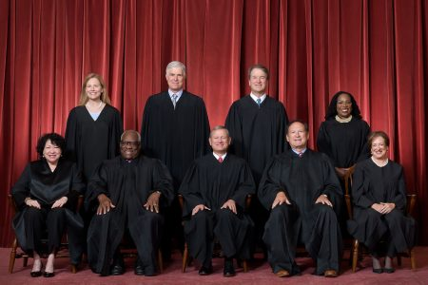
(Fred Schilling, photographer, US Supreme Court)
Against the backdrop of all of the foregoing, your humble servant posits – in merciful conclusion – that the only way a viable resolution of the enigma can take place will be for the Supreme Court, in an appropriate case, to either render a binding decision, or at minimum have one or more Justices articulate their views in an “opinion relating to an order (denying certiorari)” discussed here.
Alternatively, a constitutional amendment could suffice, but the likelihood of that succeeding before the next general election takes place is remote. Accordingly, the first alternative is the more attractive. But at the end of the day, the spectacular indifference of the electorate, the judiciary and the mainstream media suggests that “nobody cares,” and that the status quo will simply persist unchanged. The CRS narrative rules. Move along, serfs…, nothing to see here….
Your servant posits that the Founders would not be pleased…, and perhaps even disappointed.., and some might even be angry.

