Actor Who Plays the Devil on History's 'The Bible' Looks Like Obama
March 18, 2013

Mohamen Mehdi Ouazanni as Satan in History's "The Bible." (screengrab/History)
The actor who plays the devil on the History channel's "The Bible" bears more than a passing resemblance to President Obama, a fact that hasn't gone unnoticed on social media.
So, was it intentional? Responding to the speculation, the History released a statement saying, "History channel has the highest respect for President Obama. The series was produced with an international and diverse cast of respected actors. It's unfortunate that anyone made this false connection. History's 'The Bible' is meant to enlighten people on its rich stories and deep history."
Executive Producers, Mark Burnett and Roma Downey called the connection "utter nonsense." And Downey said, "Both Mark and I have nothing but respect and love for our President, who is a fellow Christian. False statements such as these are just designed as a foolish distraction to try and discredit the beauty of the story of 'The Bible.'"
[Related: 'The Bible' Producers Couldn't Find Jesus … Until He Came Walking Through Their Garden]
False or not, people are tweeting about the brewing controversy. Conservative pundit Glenn Beck, who has called "The Bible" one of the most important shows of the decade, was among the first to point out the similarities between the actor and the president.
Beck isn't the only guy to see the uncanny resemblance. Filmmaker Judd Apatow joked, "Now I must continue my 12 year survivor boycott," a reference to the fact that "The Bible" is produced by "Survivor" honcho Mark Burnett. Others weren't so much offended as they were confused. Twitter user @texas1214 wrote, "LOL! Why does the devil in 'The Bible' look exactly like President Obama." And @Mediaite wrote, "Obama As The Devil? The History Channel's The Bible's Stunning Look-alike."
The actor's name is Mohamen Mehdi Ouazanni. According to his IMDb page, he has appeared in several religion-focused television-movies, including a 2006 adaptation of "The Ten Commandments" and a 2000 film called "In the Beginning." Burnett and Downey said, "He has previously played parts in several Biblical epics -- including Satanic characters long before Barack Obama was elected as our President."
The Hollywood Reporter points out that Burnett has donated funds to Democratic candidates in years past, including to President Obama in 2008 and the Democratic National Committee in 2009.
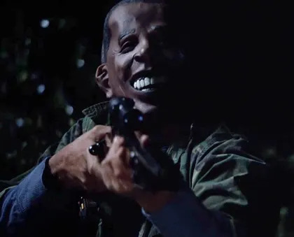
This isn't the first time an American president made an unintentional cameo in a high-profile TV event. On HBO's "Game of Thrones," show creators admitted they used a rubber recreation of George W. Bush's severed head. Co-creator David Benioff said, "It's not a choice, it's not a political statement. It's just, we had to use what heads we had around." Also, HBO's "True Blood" drew criticism for filming a scene in which disguised gunmen wore Obama masks while firing weapons.

https://www.yahoo.com/entertainment/news/actor-who-plays-the-devil-on-history-s--the-bible--looks-like-obama-174517707.html

