 Palmetto Publishing
Phone: 888-457-9395
Info@PalmettoPublishing.com
www.PalmettoPublishing.com

For Immediate Release
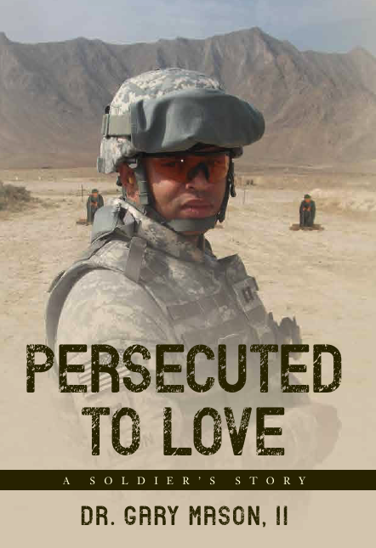
US Army veteran shares transformational experience of overcoming racism

“Persecuted to Love: A Soldier’s Story” by Dr. Gary Mason, II
ISBN: 978-1-63837-580-7
Publication Date: Available now on Amazon

A veteran of the US Army, Dr. Gary Mason, II was subjected to a racist altercation while serving in a cavalry unit in Iraq. After filing a report, Dr. Mason says he was the target of a character assassination and death threats. “The persecution really began after I made a complaint,” Dr. Mason said. “While I fought to expose institutional racism, Army leaders fought to destroy my career.” In his new memoir, he seeks to bring the truth to light and effect positive change. “The book offers hope to anyone suffering from discrimination or abuse,” Dr. Mason said. “It illustrates how to overcome persecution and succeed.” And while Dr. Mason knows the topic is controversial, he believes it is a conversation that must be had.

“Persecuted to Love” is one soldier’s story of resilience and dependence on God through a series of racist attacks. Dr. Mason relates how he pleaded with members of Congress, the White House, the Department of Justice, and even the President for protection and accountability but was ignored and ultimately forced into retirement. As a man of faith, he prayed and discovered that unconditional love and reconciliation were the only way forward. “I realized that fear was at the root of my dismissal—fear of accountability, exposure, consequences, and change,” Dr. Mason said. “Those who ignored the truth and those who continue to abuse soldiers never intended for his story to come out. But I am here to tell my story and demonstrate how God’s unconditional love is the divine solution for racism.”

“Persecuted to Love” is available for purchase online at Amazon.com. For more information about the author and his work, please visit http://www.persecutedtolove2022.com/.

About the Author
Born in Washington, D.C., Dr. Gary Mason, II is a graduate of Howard University. While attending Howard, he worked as a news aide for The Washington Post. He also interned with the Atlanta Committee of Olympic Games and signed on as a broadcast camera operator for the Atlanta Olympic Broadcasters where he became the first underwater pneumatic camera operator at the Georgia-Tech Aquatics Center and filmed over 238 races. After graduation, he married his college sweetheart and enlisted in the US Army. While serving in the army, he earned an MA in Film Production from American University and an MA in Practical Theology from Regent University. After his retirement from service, he earned a Doctorate in Military Ministry from Regent University. He is an aspiring filmmaker who co-wrote the screenplay, “PVT William Cathay – Slave to Buffalo Soldier”, with his wife. He is an expert communicator in military affairs, media planning, and military ministry.

MEDIA CONTACT:
Dr. Gary Mason, II
Dr.GMasonii@PersecutedtoLove2022.com
REVIEW COPIES AND INTERVIEWS AVAILABLE

###

