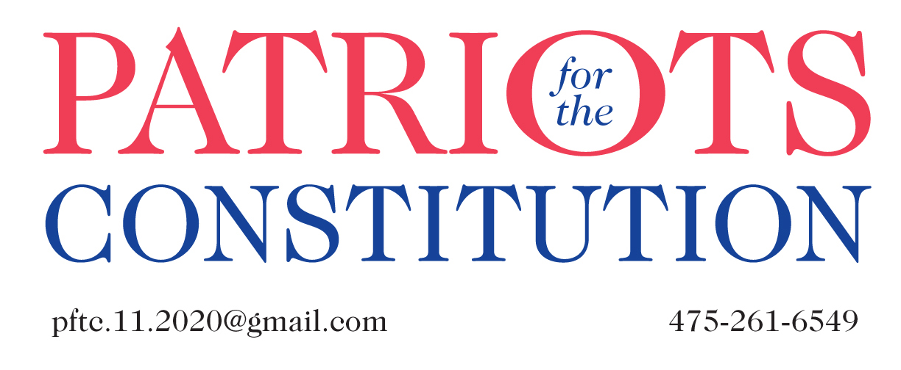

September 24, 2020

Dear Conservative Activists,
America is under attack.

Communists, Socialists, and other enemies have successfully infiltrated our political system and pose an existential threat to our and our children’s future.

The attached matrices were developed to demonstrate the degree to which they have hijacked the Democratic Party and to expose our federal and state politicians who have become their willing proxies.

The charts containing red checks display Democratic incumbents, their un-American affiliations (and resources on those organizations), newsworthy information about them, and messages about Communism that have been pushed aside and forgotten but must be dusted off. Their connections with known violent and rioting organizations, such as BLM and Antifa—both being funded by the Chinese Communist Party—need to be exposed.

Because this resource could be overwhelming, we recommend that you look up your own legislators first and then branch out to others. The CT Federal Legislators are shown first, followed by CT State Assembly Members in alphabetical order. Legislators not listed here have not demonstrated the un-American ties of their colleagues on this chart.

We hope that you will disseminate this within your organization, and to as many others as possible before this November’s elections. Let us know if you need additional information and we look forward to hearing your thoughts.

Patriots for the Constitution
pftc.11.2020@gmail.com
475-261-6549

