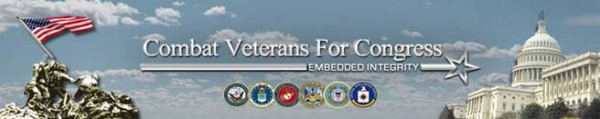

31 Combat Veterans For Congress Running in 2014—--Embedded Integrity

Cong Duncan D. Hunter, Capt-USMCR (R-CA-52)
Cong Steve Pearce, Capt-USAF (R-NM-2)
Cong Michael Coffman, Maj-USMC (Ret) (R-CO-6)
Cong John P. Kline, Col-USMC (Ret) (R-MN-2)
Cong Chris Gibson, Col-USA (Ret) (R-NY-20)
Cong Steve Stivers, Lt. Col-USANG (R-OH-15)
Cong Tim Griffin, Maj-USAR (JAG) (R-AR-2)
Cong Adam Kinzinger, Cpt-AFNG (R-IL-11)
Cong Michael Grimm, USMC/FBI (R-NY-13)
Cong Joe Heck, Col-USAR (MC) (R-NV-3)
Cong Jeff Denham, SSgt-USAF (R-CA-10)
Cong Paul Cook, Col-USMC (Ret) (R-CA-8)
Cong Scott G. Perry, Col/PA-ARNG (R-PA-4)
Cong Brad Wenstrup, Lt Col-USAR (MC) (R-OH-2)
Cong James Bridenstine, Lcdr-USNR (R-OK-1)
Cong Ron DeSantis, Lcdr-USNR (JAGC) (R-FL-6)
Cong Thomas B. Cotton, Cpt-USA (R-AR-Senate)
Cong Paul C. Broun, Lcdr-USNR (MC) (R-GA-10)
Cong Kerry Bentivolio, SFC/MI-ANG (R-MI-11)
Command Master Chief Larry Wilske, USN (Ret) (SEAL) (R-CA-53)
Col Robert L. Maness, USAF (Ret) (R-LA-Senate)
Col Larry Kaifesh, USMCR (Ret) (R-IL-8)
Col Allen Weh, USMCR (Ret) (R-NM-Senate)
Cdr Ryan Zinke, USN (Ret) (SEAL) (R-MT-1)
Cdr Jeff Gorell, USNR, Esq. (R-CA-26)
LTC Steve Russell, USA (Ret)(Ranger) (R-OK-5)
LTC Sean Seibert, USAR (R-TX-18)
Maj Arthur Moore, USMA ’00, USANG (Ranger Qualified)
Maj Lee M. Zeldin, USAR (JAG) (R-NY-1)
Lcdr Paul Chabot, USNR (R-CA-31)
CPT Christopher E. Day, USA (Ranger Qualified) (R-NY-17)

http://www.CombatVeteransForCongress.org

