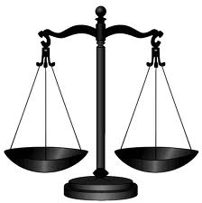
Unified New York Common Law Grand Jury
Psa 89:14 Justice and judgment are the habitation of thy throne: mercy and truth shall go before thy face.
• Phone (845) 233-6560 • Fax (888) 891-8977

October 4, 2013
New York Supreme Court Chief Clerks
New York County Clerks
Dear Clerks;
It has come to the attention of “We the People” of the New York’s Common Law County Grand Juries that Chief Administrative Judge A. Gail Prudenti has sent a directive in the form of a letter as pertaining to the Common Law Grand Juries in New York State.
In this directive Judge Prudenti, and others, have taken it upon themselves to order all county clerks and court clerks to reject any filings pertaining to the constituted common law grand juries. This is a felony act of treason.
“We (judges) have no more right to decline the exercise of jurisdiction which is given, than to usurp that which is not given. The one or the other would be treason to the Constitution." -- Cohen v. Virginia, (1821), 6 Wheat. 264 and U.S. v. Will, 449 U.S. 200.
Let this serve as a notice to you, the elected and appointed public servants of “We the People” that this directive of Judge Prudenti could be construed as a felony act of treason and a usurpation of her powers as a member of the branch of the judicial arm of our constitutional New York Government, so govern your actions accordingly.
All elected officials, county clerks, chief court clerks, as well as Judge Prudenti have an oath of office they should have sworn to uphold as a condition of holding their office. This action of the judge and county clerks is a direct assault and breach of the peace on the people of New York and infringes on their unbridled right to form and run grand juries for the People’s Constitutional oversight without interference from the courts they operate out of.
Please be advised that over the next few days and weeks the remaining various counties will be establishing their grand juries and every refusal will be noted and added to the presented papers each actor weather judge, clerk, or other will be held to answer to the full remedy allowed under the law, both civilly and criminally. “Following orders” or being ignorant of the law is not an excuse of the law and will not be tolerated by the People. Make no mistake about our filing with the court and the county clerks. We are not asking permission of our elected public servants, we are merely announcing and memorializing the reestablishing of this lawful body.

As the Grand Jury (consentors) arises out of the People and owes its existence to no other branch of government. The Grand jury normally operates under the auspices of the court and should convene in that edifice whenever possible but it does not need permission or even that brick and mortar to operate.
Just as the courts could operate out of a tent in times of extreme calamity, so can the grand jury convene a court of record wherever else it is necessary in order to carry out its lawful duty; Until such time as the decorum authority and order of those court rooms be restored we expect nothing less. We the People counsel you to read carefully the authorities that the common law grand juries have provided you, our public servants with. If you do not understand these authorities you should seek legal advice on your responsibility under the law before you decide to comply with judge Prudenti’s treasonous breach of the peace order.

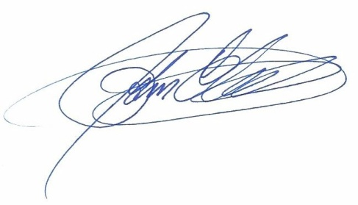
Respectfully,

Administrator, Unified NY Grand Jury

Attachments: True Bill of indictment [2 pages], Copy of letter to conspirators’ [6 pages]

