“The Enchanted Isles”
A Concert to Benefit
Hurricane Relief Efforts
Sunday October 8th at 4:00pm

Music featuring 17th & 18^{t}Century
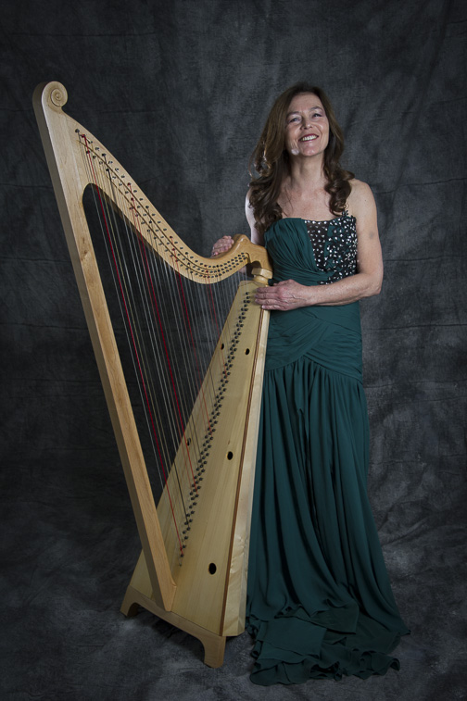
English music of Handel, Purcell, and
Others, performed by
Lyra New York Baroque
Program Young Artists and
Zoe Vandermeer

Free Will Offering for Episcopal Hurricane Harvey and Irma Relief Funds

Trinity Episcopal Church
345 Main Street, Portland
860-342-0458

